# STREAMLINE bioinformatics workshop

**Installation instructions (part 1)**

To follow the hands-on sessions for the workshop you will need the following software installed on your computer: PathVisio, Cytoscape, and R.

**Please make sure to install this software in the week before the workshop so we can help you with any problems. During the workshop we will have no time to sort out installation problems!**

For help with installation ask: [friederike.ehrhart@maastrichtuniversity.nl](mailto:friederike.ehrhart@maastrichtuniversity.nl)

## 1. Install PathVisio

1. Select the suitable installation for your operating system from [Download PathVisio 3.3.0](https://pathvisio.org/downloads) on your computers and then use this online guide for installation: <https://pathvisio.org/tutorials/installation_guide.html>.
2. Open PathVisio, it should look like this:

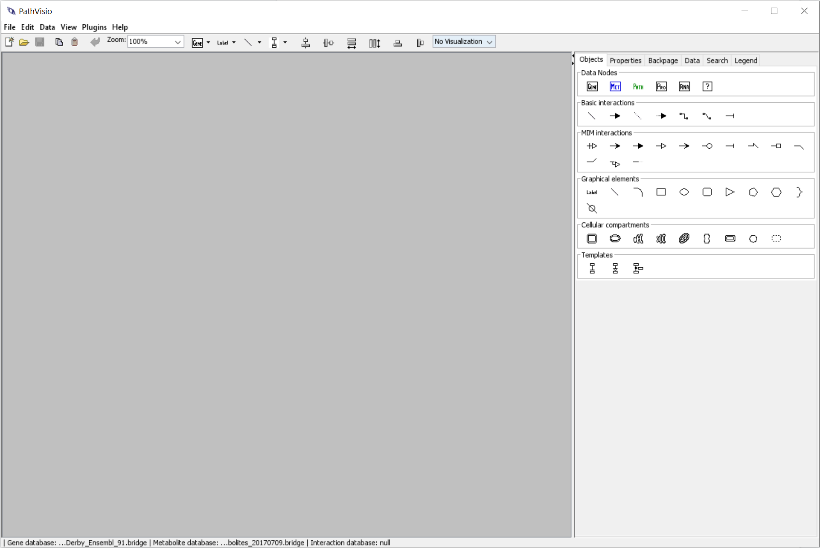

## 

## 2. Install WikiPathways plugin to PathVisio

1. Start PathVisio
2. Go to Plugins > Plugin Manager
3. Select the “WikiPathways” plugin and click “install”

PathVisio has now a direct connection to the database so you can open, upload, and update the pathways in the database.

## 3. Download required databases for PathVisio

For looking up identifiers in PathVisio and visualizing data on the pathways, we need to load to identifier mapping databases (one for genes/proteins and one for metabolites).

The **human gene identifier mapping database** is important for pathway curation, data analysis, and visualization.

The **metabolite identifier mapping database** is relevant if you curate metabolic pathways or visualize metabolomics data.

1. Go to the database download page: <https://bridgedb.github.io/data/gene_database/>
   1. From the Gene / Protein ID mapping databases download the human one or use this direct download link: <https://zenodo.org/record/7781913/files/Hs_Derby_Ensembl_108.bridge?download=1>
   2. From the “Other ID mapping databases” download the Metabolites database or use this direct download link: <https://figshare.com/ndownloader/files/36197283>
   3. Move the files to a folder where you can find/access them easily.
2. Open PathVisio and load the mapping databases.
   1. Data -> Select Gene database -> go to the folder with the mapping databases and select the Hs_Derby… file.
   2. Data -> Select Metabolite database -> go to the folder with the mapping databases and select the metabolites_... file.
   3. If done correctly, you should see this at the very bottom of PathVisio:



## 4. Install Cytoscape

1. Download and install Cytoscape following the instructions here: <https://cytoscape.org/download.html>

2. Install WikiPathways and CyTargetLinker addon: in the toolbar go to “Apps” -> “AppStore” -> “Show AppStore”. Search “Wikipathways”, download and install. Same for “CyTargetLinker”.

3. Go to <https://cytargetlinker.github.io/pages/linksets> - there are the different linksets available for CyTargetLinker app. Please download the linkset files and put them in a folder. In the tutorial we will use the following:

Gene-Pathway linksets from WikiPathways and Reactome

<https://figshare.com/ndownloader/files/35098210>

<https://figshare.com/ndownloader/files/35098207>

Drugs-Drug targets from DrugBank:

<https://ndownloader.figshare.com/files/21623682?private_link=32aae0822ffdd1f5660b>

## 5. Install R

Install R and R Studio following this guide: <https://www.stat.colostate.edu/~jah/talks_public_html/isec2020/installRStudio.html>

Please use the most actual version for R – for this workshop it is

R version 4.3.2

RStudio-2023.09.1-494

Install the following packages: DESeq2, WGCNA, ggplot2, tidyr, dplyr, stringr

You can use the following code to install the packages via BiocManager if needed:

#install required packages and load them

if (!requireNamespace("BiocManager", quietly = TRUE))

install.packages("BiocManager")

BiocManager::install("DESeq2")

BiocManager::install("WGCNA")

BiocManager::install("ggplot2")

BiocManager::install("tidyr")

BiocManager::install("dplyr")

BiocManager::install("stringr")